Wrestling Singlets Solid Black Asics
Singlets will have a white “O” on the front for Oxford and a full colored
American Flag on the back.
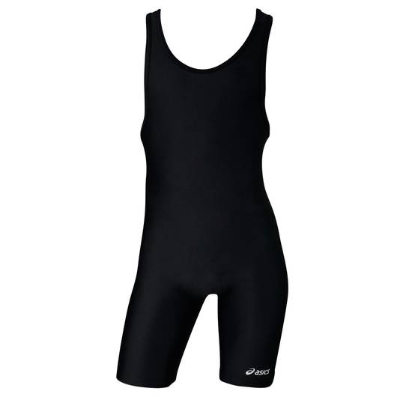
SIZE CHART COST $40.00
4XS 40 – 50 LBS
3SX 55 – 75 LBS
2XS 75 – 95 LBS
XS 95 – 115 LBS
S 115 – 135 LBS
M 135 – 160 LBS
L 160 – 190 LBS
XL 190 – 220 LBS

Wrestlers Name_____________________________________________________

Size______________________________ Weight__________________________

Phone Number______________________________________________________

Email Address_________________________ TOTAL PAID:________________

